Module (CSS and CSS 3) -2

1. What are the benefits of using CSS?

* CSS offer several advantages, including improved website aesthetics easy

Updates across multiple pages , faster loding time , and the ability to create

Responsive designs that adapat to vatious devices.

1. What are the disadvantages of CSS?

* Browser compatibility. CSS may render differently in various web browsers , leading to

Inconsistencies in the visual presentation.

* Cross-browser Issues.
* Security Issues.
* Extra Work for Developers
* Confusion due to many CSS levels

1. What is the difference between CSS2 and CSS3?

* The biggest difference between CSS2 and CSS3 is that CSS3 Has been split into difference

Sections, called modules.

🡪 Each of these mudules is making its way through the w3c in various stages of the

Recommendation process.

EX :-

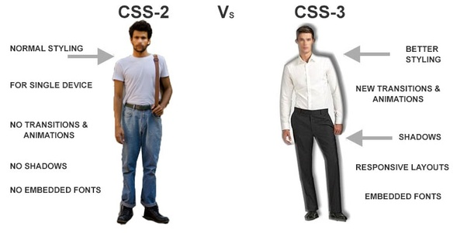

1. Name a few CSS style components?

* At its most basic level , css consists of two components. Properties:
* These are human-readable identifiers that indicate which stylistic features

You want to modify.

EX:-

Font-size , width , background-color .

1. What do you understand by CSS opacity?

* The op apacity CSS property sets the opacity of an element.
* Opacity is the Degree to which content behind an element is hidden , and is the opposite

Of transparency.

EX:-

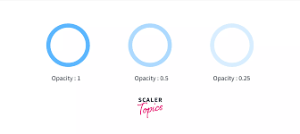

1. How can the background color of an element be changed?

* To add background-color in HTML, use the CSS background-color property.
* Set it to the color name or code you want and place it inside a style attribute.
* Then add this style attribute to an HTML element , like a table , heading , div, or span tag.

EX:-

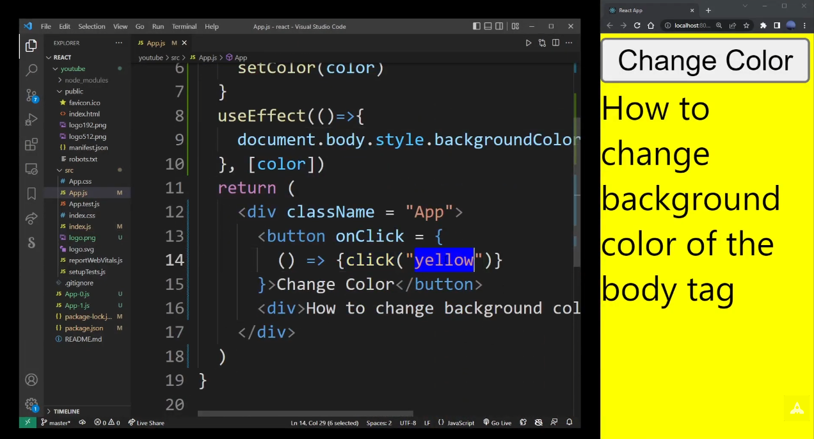

1. How can image repetition of the backup be controlled?

* This task can be achieved by using the background-repeat property that will help Us to control the repetition of the image.
* The background-repeat property in CSS is used to repeat the background image Both Horizontally and vertically.
* It also decides whether the background image will be Repeat Or not .

EX:-

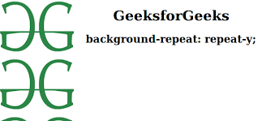

1. What is the use of the background-position property?

* The background-position CSS property sets the initial position for each background Image .
* The position is relative to the position layer set by backgrouond-origin.

Ex:-

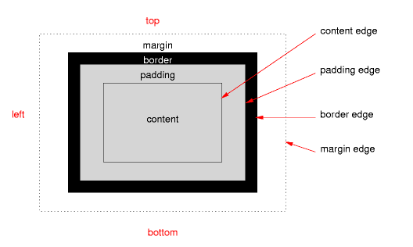

1. Which property controls the image scroll in the background?

* The background-attachmnet property sets whether a background image scrolls

With the rest of the page , or is fixed.

Ex:-

Background-attachment: scroll | fixed | local | initial | inherit ;



1. Why should background and color be used as separate properties?

* There are two reasons behind this : It enhances the legibility of style sheets .
* The background property is a complex property in CSS , and if it is combined with color,

The complexity will further increase.

EX:-

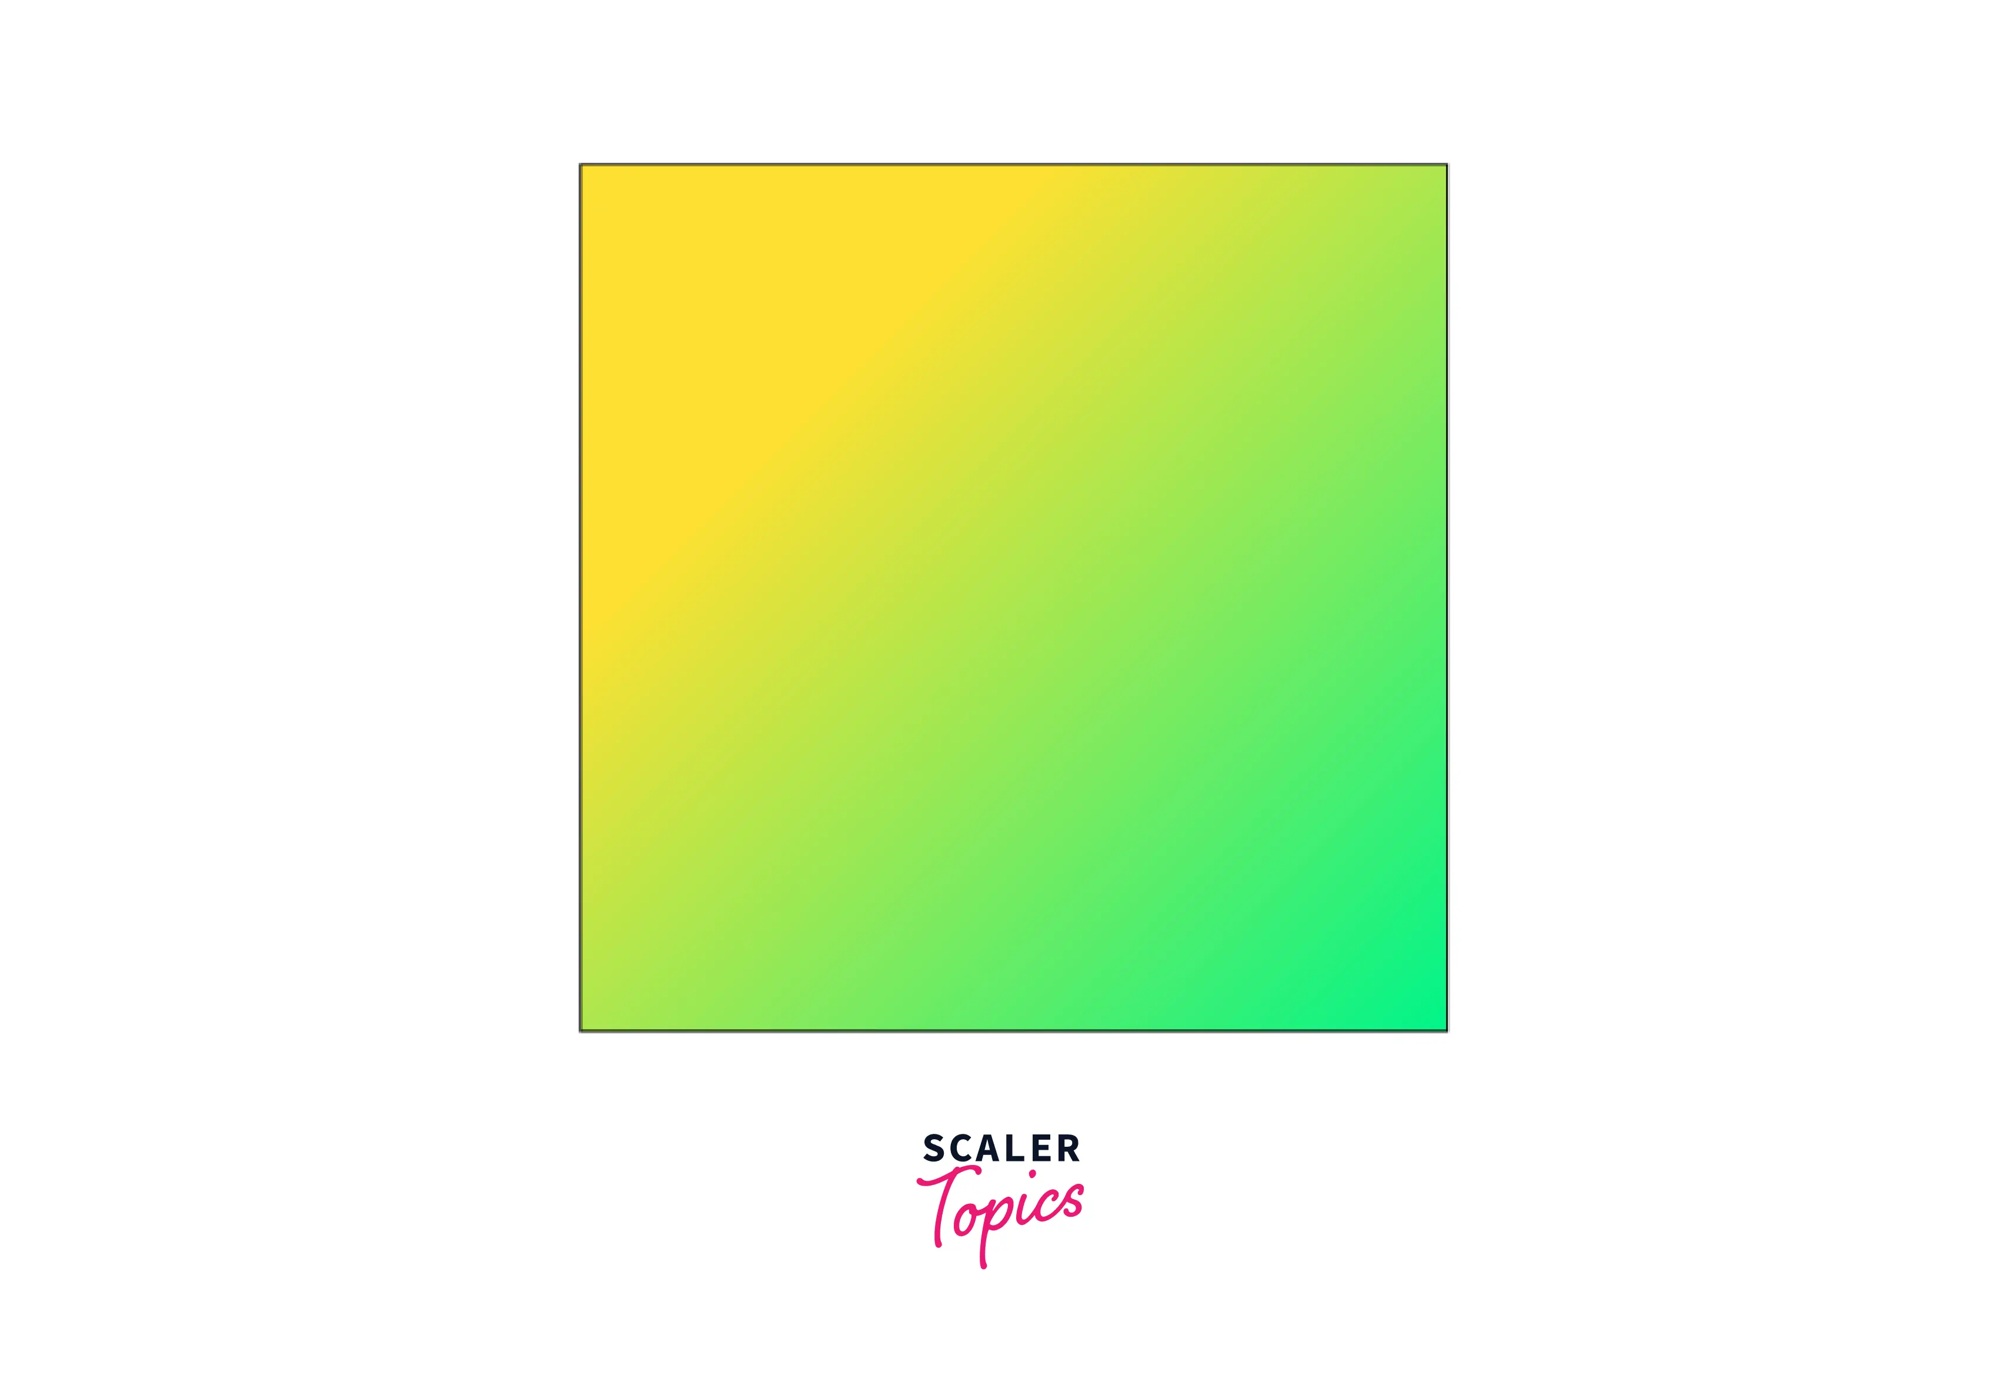

1. How to center block elements using CSS1?

* To horizontally center a block element ( like <div> ), use margin: auto; setting the width

Of the element will prevent it from stretching out to the edges od this container .

EX:-

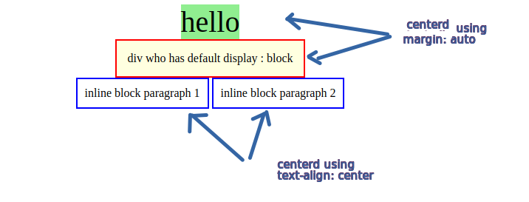

1. How to maintain the CSS specifications?

* The CSS specifications are maintained by the world wide web consortium.

EX:-

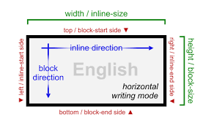

1. What are the ways to integrate CSS as a web page?

* CSS may be added to HTML in three different ways.
* To style a single HTML element on the page, use Inline CSS in a style attribute.
* By adding CSS to the head section of our HTML document, we can embed an internal stylesheet.
* We can also connect to an external stylesheet that separates our CSS from our HTML.

EX:-

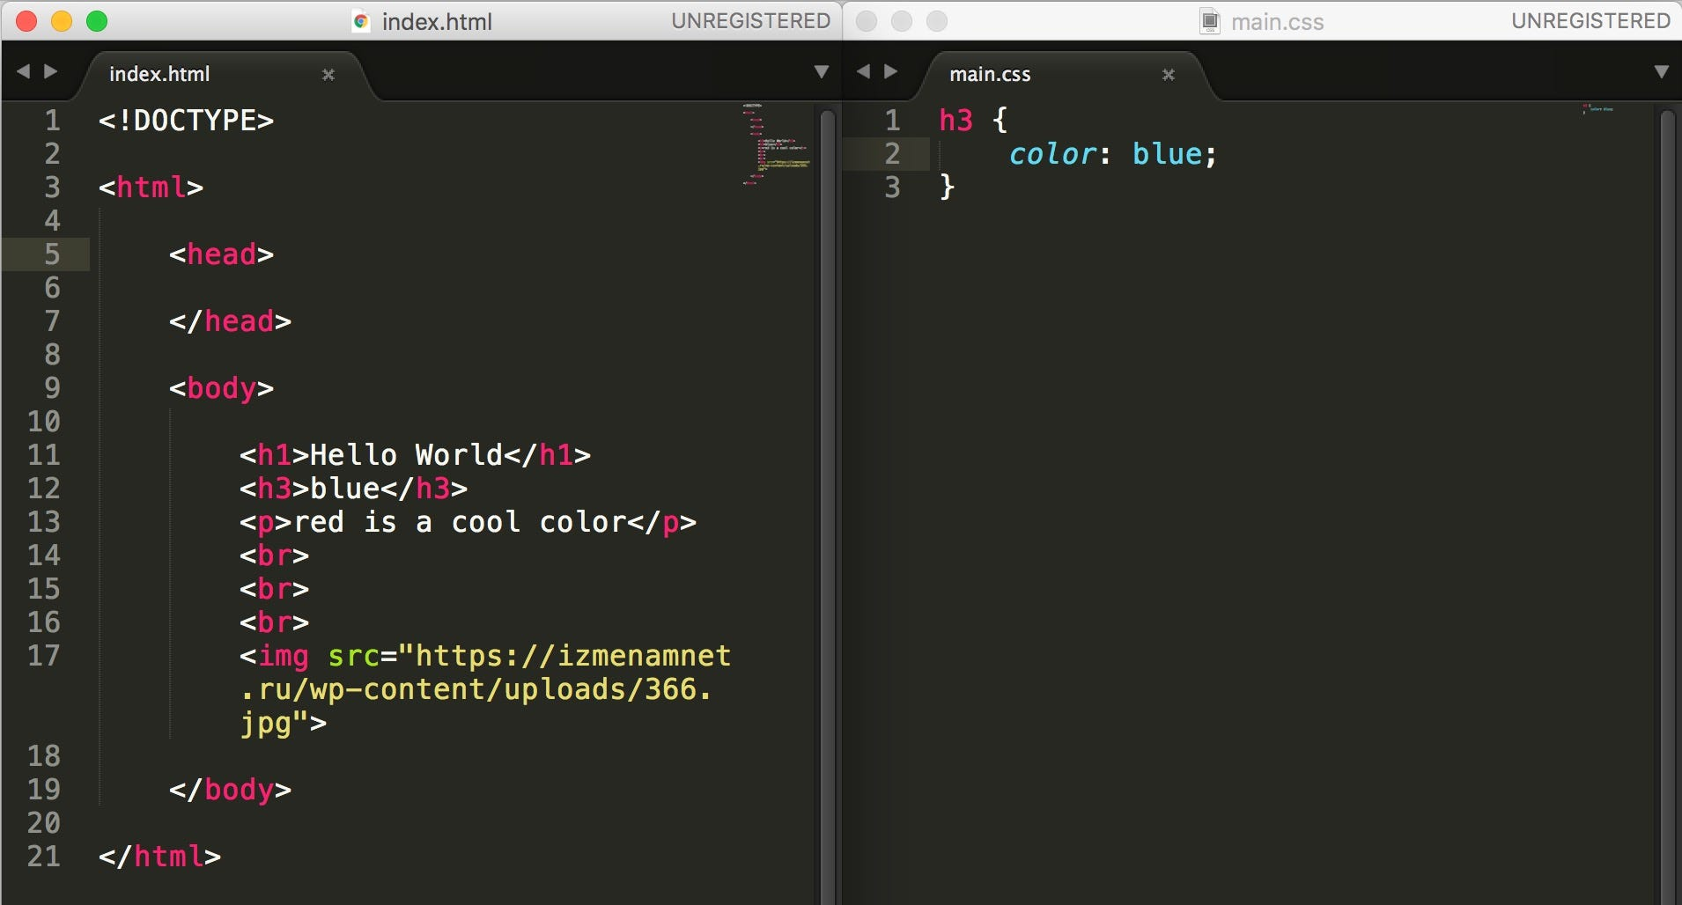

1. What is embedded style sheets?

* An embedded style sheet is declared within the <head> element of an XHTML document.
* It applies to the whole document, rather than just one element.
* Each style declaration (or CSS rule) gets applied to everything in the document that matches that rule.

EX:-

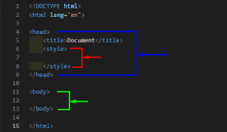

1. What are the external style sheets?

* An external style sheet is a separate CSS file that can be accessed by creating a link within the head section of the webpage.
* Multiple webpages can use the same link to access the stylesheet.
* The link to an external style sheet is placed within the head section of the page.

EX:-

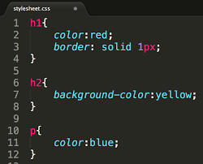

1. What are the advantages and disadvantages of using external style sheets?



Disadvantages Advantages

🡪 It take a lot of time to create 🡪 Easy to create a webpage.

Anything that even resembles

A webpage.

🡪 it isn’t as flexible as other 🡪 it’s plain text so it’s easy to

Webpage developers like edit.

Dreamweaver.

🡪 it is not centralized, all the 🡪 Fast to download because

Webpages must be edited the text is compressible.

Separately.

🡪 Better website speed 🡪 Cross-browser Issues.

🡪 Easier to maintain 🡪 Security Issues.

1. What is the meaning of the CSS selector?

* A CSS selector is the first part of a CSS Rule.
* It is a pattern of elements and other terms that tell the browser which HTML elements should be selected to have the CSS property values inside the rule applied to them.

EX:-

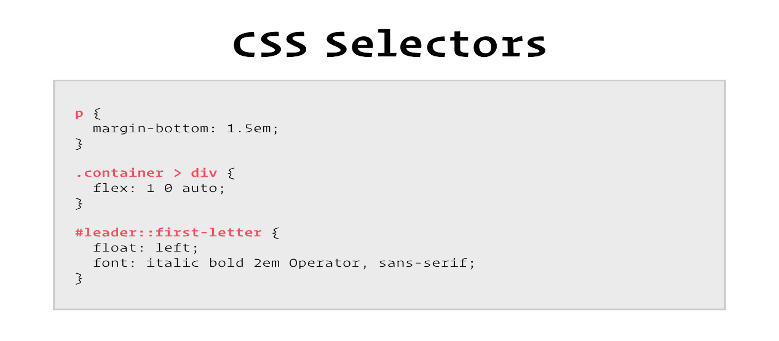

1. What are the media types allowed by CSS?

* The @media rule is used in media queries to apply different styles for different media types/devices.
* Media queries can be used to check many things, such as: width and height of the viewport. width and height of the device.

EX:-

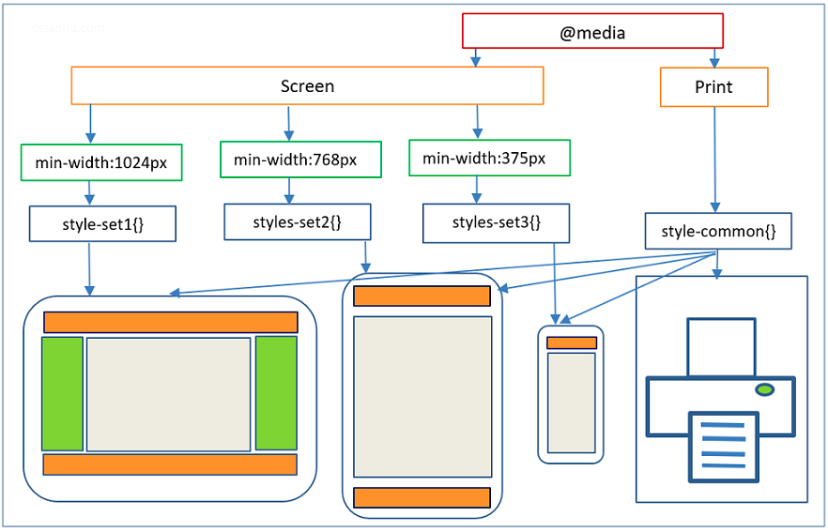

1. What is the rule set?

* A CSS rule set contains one or more selectors and one or more declarations.
* The selector(s), which in this example is h1 , points to an HTML element.
* The declaration(s), which in this example are color: blue and text-align: center style the element with a property and value.

Ex:-

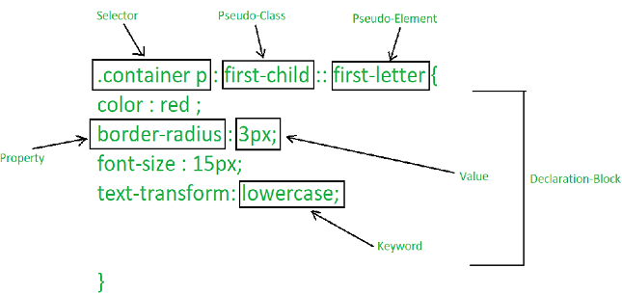

1. Create Layouts ?

* CSS page layout techniques allow us to take elements contained in a web page and control where they're positioned relative to the following factors: their default position in normal layout flow, the other elements around them, their parent container, and the main viewport.

EX:-

